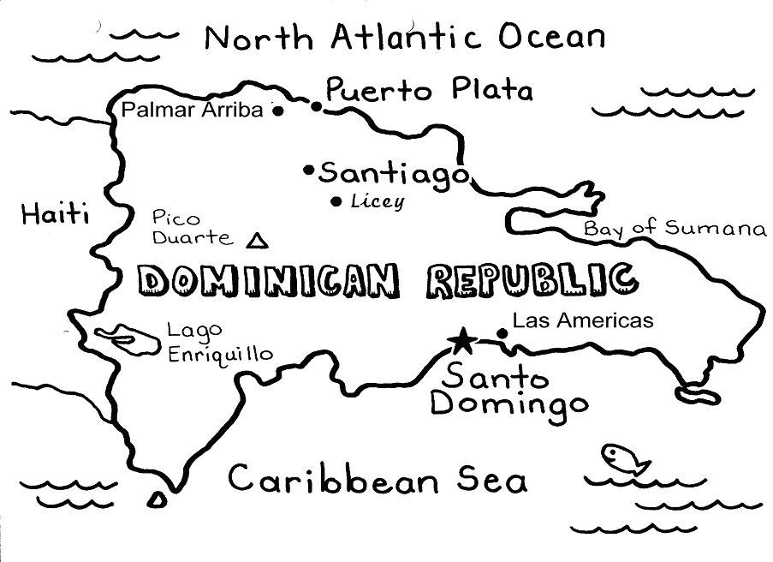
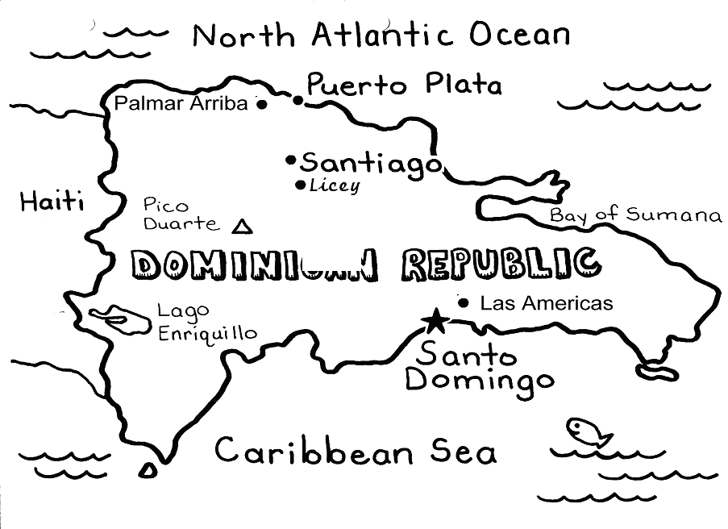
Home for the Kreys; Pastor Walter Ries Jr.; and Disability Outreach Specialist Danelle Putnam.
10 confirmations, 2 baptisms in Feb. By God’s grace and after careful consultation with our doctors, psychologists and psychiatrists, all 6 orphans are off the medications they received while in institutionalized care. Thank God for Dr. Marisol Martinez & her constant attention to these children.
Feb 6 four adults confirmed. 1st Lord’s Supper celebrated. 8 more adults in confirmation classes.
On February 25th, after 9pm on a Friday night, the container from Orphan Grain Train arrived! Inside were gifts from the summer CPH VBS offerings, and also furniture for the group home, school and valuable therapy equipment. Thanks to all involved.
Feb. 11-15 intensive seminary course was 1st in newly developed 4 year seminary curriculum which will be offered by the seminary in Argentina . Pray for students Luis, Yban, Josef, Willy, Manuel, Jon & Pedro. Feb. 14th, Vicar Gaspar passed three hour colloquy exam He was called by Amigos de Cristos congregation , to be ordained/installed Mar. 13. Brian & Jeanette Keller arrived Feb. 9..

